Academic Task Number: CA-2 (Test-1) SET-D Course code: ECE-249 Section: K22
Date of allotment: Course title: BEEE Roll No.
Date of submission: Maximum Marks: 30 Reg. No.
Academic Task Type: Subjective
Q. No. | Question Statement | Course Outcome | Bloom’s level | Marks
Q1 | a) An alternating voltage is given by v = 282.8 sin 314t volts. Find (i) the rms voltage, (ii) the frequency and (iii) the instantaneous value of voltage when t = 4 ms.  b) Determine the phase difference between v = 30 cos(ꭃt + 20º) and i = 30 sin(ꭃt + 70º). | CO2 | L5: Analysis | 5
Q2 | Draw the connection diagram of Step Up transformer. The number of turns in one winding is 50 and number of turns in secondary winding is 80, if we give 50 V supply voltage to primary winding find out the voltage across secondary winding. (5) | CO2 | L3: Apply | 5
Q3 | Discuss in brief superposition theorem with one example. | CO1 | L1:Remember | 5
Q4 | Find the total resistance of the circuit across a and b.  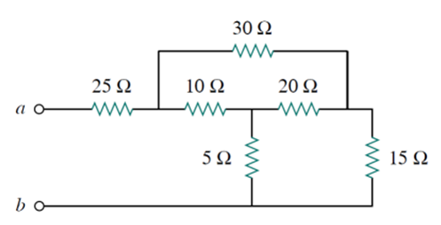 | CO1 | L3: Apply | 5
Q5 | A series RLC circuit with R=40Ω, L=0.04H, C= 10μF connected across 220V, 50Hz. Write the expressions for instantaneous voltage and current equations at 30⁰ phase difference. Also calculate the Impedance, current, power consumed by the resistor and energy stored in the inductor and capacitor | CO1 | L1: Apply | 5
Q6 | Determine the current through branch AB by using any method.  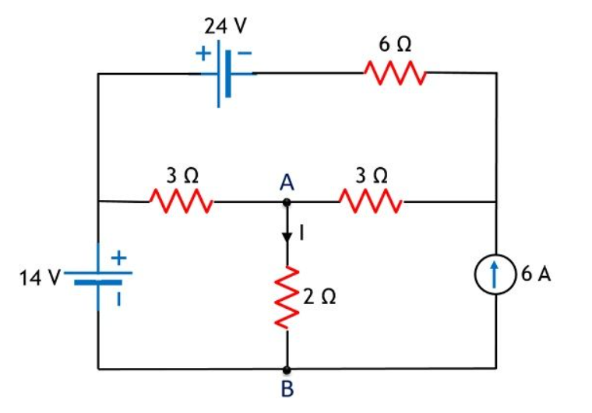 | CO2 | L3: Apply | 5

